|  |  |
| --- | --- |
| Date | 30th September 2022 |
| Team ID | PNT2022TMID53078 |
| Project Name | Car Resale Value Prediction |

**Data Flow Diagram:**

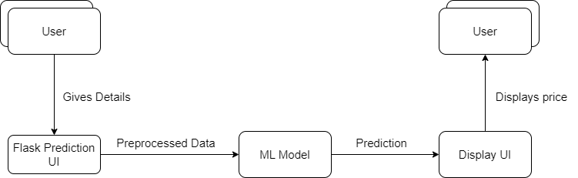

**User Stories:**

|  |  |  |  |  |  |  |
| --- | --- | --- | --- | --- | --- | --- |
| **User Type** | **Functional Requirements** | **User Story Number** | **User Story** | **Acceptance Criteria** | **Priority** | **Release** |
| Customer | Entering Car Details | USN-1 | The user enters the necessary car details | All the mandatory fields are filled | High | Sprint 1 |
| Customer | Viewing valuation | USN-2 | The user’s car’s value is predicted by model | The value is displayed | High | Sprint 1 |
| Admin | Updating model | USN-3 | The admin can update the ML model after modifying it. | The ML model is properly loaded into the app. | High | Sprint 2 |